Data Modelling and Management Apply stage DAL8 SQ A3.3

Contents
Task 1: Conduct research on data modelling & management within your organisation 5
Data models 5
Tools and technologies 5
Standards and best practices 5
Data structures 5
Naming conventions 5
Documentation and resources 5
Task 2: Conduct research on data sources 6
Identify data sources 6
Types of information 6
Due diligence 6
Data gathering methods 7
Batch processing 7
Streaming 7
Data important mechanisms 7
(Screenshots of ETL using PowerQuery) 7
Task 3: Identify reference data tables 8
Identify reference data tables 8
List of possible reference tables and attributes. 8
Reference Tables: 8
Task 4: Identify data entities 9
Find data entities 9
List of entities for Movies database 9
Entities: 9
JSON vs Excel 10
Your preferences 10
Task 5: Create an Entity-Relationship (ER) diagram 11
Create the ER diagram 11
Screenshot of ERD 11
Task 6: Create a basic design document 12
Data Dictionary for the Movies Database (Design Document) 12
Task 7: Compose CREATE statements 13
Screenshots of SQL Create Statements (DDL – Data Definition Language) 13
Task 8: Compose SQL statements 14
Select Statements 14
Screenshots of SQL and displayed results (DML Data Manipulation Language) 14
Task 9: Create a basic security plan 15
Add Screenshots of Systems Administrator accessible areas 15
Identify user roles 15
Define access levels 15
User authentication: 15
Authorisation and permissions: 15
Data encryption 15
Audit trails and logging 15
Regular user access reviews (optional) 15
Training and awareness (optional) 15
Task 10: Create a basic governance plan 16
Data quality assurance 16
Data update mechanism 16
Right to edit 16
Data removal mechanism 16
Privacy and consent management 16
Data retention policies (optional) 16
Documentation and communication (optional) 16
Regular review and compliance monitoring (optional) 16
Task 11: Assess the pros and cons of a big data system and data warehousing 17
Dataset characteristics 17
Scalability requirements 17
Complex data processing 17
Real-time data processing 17
Data integration and centralisation 17
Data governance and compliance 17
Cost and resource considerations 17
Analytics and insights 17

Task 1: Conduct research on data modelling & management within your organisation
K&Ps: K3, P1, P3 (Part 1); K1, K7, K8 (Part 2)

Data models
Perhaps include some screenshots of the type of data structures used in your organisation (not necessarily the actual database schemas used but example of the type)

Tools and technologies

Standards and best practices

Data structures

Naming conventions

Documentation and resources

Task 2: Conduct research on data sources
K&Ps: K1, K6 (Part 1), K9, K10

Identify data sources

Types of information

Due diligence

Data gathering methods

Batch processing

Streaming

Data important mechanisms

Task 3: Identify reference data tables
K&Ps: K11 (Part 1)

Identify reference data tables

List of possible reference tables and attributes.

Reference Tables:

Task 4: Identify data entities
K&Ps: K7, K8 (Part 1); K2 (Part 2)

Find data entities

List of entities for Movies database

Entities:

JSON vs Excel

Your preferences
Paragraph about which file format would be best suited for and why:
An online database to transfer data from a web page or intranet form to a database stored on a web server:
Importing data into SQL Server or PowerBi in order to create data tables or a report with visualisations.

Task 5: Create an Entity-Relationship (ER) diagram
K&Ps: K4, K5, P4 (Part 1); K5, K11 (Part 2)

Create the ER diagram

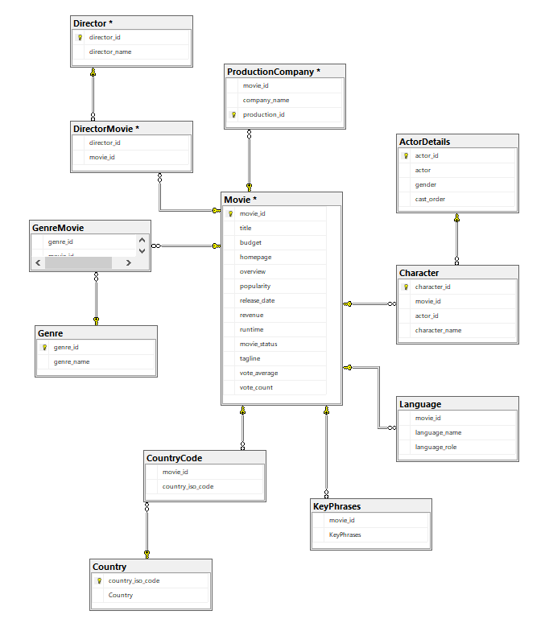

Task 6: Create a basic design document
K&Ps: K2, P5, P7, P8 (Part 1); K4, K6, K9, K10, P1, P3 (Part 2)

Data Dictionary for the Movies Database (Design Document)

Database - Movies
Entity Name - ActorDetails
Description - Table containing details of actors recorded in the Movies database
Key | Attribute | Data Type | Constraints/Comments
PK | actor_id | int | Not Null - Related to the Character table via one - to - many (actor_id)
 | actor
 | gender

Database - Movies
Entity Name - Movie
Description - Table that holds details of movies on the database
Key | Attribute | Data Type | Constraints/Comments
PK | movie_id | int | Not Null - Always required
FK | director_id | int | Not Null - Foreign Key from Directors table to create one - to - many relationship
 | title
 | budget
 | homepage
 | overview
 | popularity
 | release_date
 | revenue
 | runtime
 | movie_status
 | vote_average
 | vote_count

Database - Movies
Entity Name - Director
Description - Table that holds records of directors involved with the movies stored in the database.
Key | Attribute | Data Type | Constraints/Comments
PK | director_id | int | Not Null - Related to Movie table to create one - to - many relationship
 | director_name

Database - Movies
Entity Name - Character
Description - Table that holds records of characters involved with the movies stored in the database.
Key | Attribute | Data Type | Constraints/Comments
PK | character_id | int | Not Null
FK | movie_id | int | Not Null - Foreign Key from Movie table to create one - to - many relationship
FK | actor_id | int | Not Null - Foreign Key from ActorDetails table to create one - to - many relationship
 | cast_order

Database - Movies
Entity Name - DirectorMovie
Description - Table that acts as a bridging table between Movie and Director - Several directors can direct the same movie (many-to-many)
Key | Attribute | Data Type | Constraints/Comments
FK | movie_id | int | Not Null - Foreign Key from Movie table to create one - to - many relationship
FK | director_id | int | Not Null - Foreign Key from Director table to create one - to - many relationship

Database - Movies
Entity Name - Languages
Description - Reference table that holds records of languages involved with the movies stored in the database.
Key | Attribute | Data Type | Constraints/Comments
FK | movie_id | int | Not Null - Foreign Key from Movie table to create one - to - many relationship
 | language_name |  | Null - some languages not recorded
 | language_role

Database - Movies
Entity Name - Genre
Description - Reference table that holds records of genres involved with the movies stored in the database. Links to the movies table via bridging table GenreMovie
Key | Attribute | Data Type | Constraints/Comments
PK | genre_id | int | Not Null - One to many relationship to the GenreMovie table (many to many with Movie table
 | genre_name

Database - Movies
Entity Name - GenreMovie
Description - Bridging table to avaoid many -to - many relationship between Genre and Movie tables
Key | Attribute | Data Type | Constraints/Comments
FK | genre_id |  | Not Null
FK | movie_id |  | Not Null

Database - Movies
Entity Name - Country
Description - Table liting original countries for movies.
Key | Attribute | Data Type | Constraints/Comments
PK | country_iso_code | char(4) | Not Null - Related via many to many bridging table (CountryCode) to Movie table
 | country

Database - Movies
Entity Name - CountryCode
Description - Bridging table to avaoid many -to - many relationship between Country and Movie tables
Key | Attribute | Data Type | Constraints/Comments
FK | movie_id | int | Not Null
FK | country_iso_code | char(4) | Null - Some movies are unlisted

Database - Movies
Entity Name - KeyPhrases
Description - Table listing some key phrases connected with movies in the database.
Key | Attribute | Data Type | Constraints/Comments
FK | movie_id | int | Not Null - Foreign Key from Movie table to create one - to - many relationship
 | key_phrases

Database - Movies
Entity Name - ProductionCompany
Description - Table listing movie production companies
Key | Attribute | Data Type | Constraints/Comments
PK | production_co_id | int | Not Null - Foreign Key from Directors table to create one - to - many relationship
 | company_name

Database - Movies
Entity Name - MovieProduction
Description - Bridging table to avoid many -to - many between Movies and ProductionCompany
Key | Attribute | Data Type | Constraints/Comments
PK | production_co_id | int | Not Null
 | movie_id

Task 7: Compose CREATE statements
K&Ps: P9, P10 (Part 1); P2 (Part 2)

Screenshots of SQL Create Statements (DDL – Data Definition Language)

Task 8: Compose SQL statements
K&Ps: P9, P10 (Part 1); K2, P2, P4 (Part 2)

Select Statements

Screenshots of SQL and displayed results (DML Data Manipulation Language)

Task 9: Create a basic security plan
K&Ps: K12, K13, P2, P11 (Part 1); K14, K15, P5 (Part 2)

Add Screenshots of Systems Administrator accessible areas

Identify user roles

Define access levels

User authentication:

Authorisation and permissions:

Data encryption

Audit trails and logging

Regular user access reviews (optional)

Training and awareness (optional)

Task 10: Create a basic governance plan
K&Ps: P6, P11 (Part 1); K3, K16, P6, P7 (Part 2)

Data quality assurance

Data update mechanism

Right to edit

Data removal mechanism

Privacy and consent management

Data retention policies (optional)

Documentation and communication (optional)

Regular review and compliance monitoring (optional)

Task 11: Assess the pros and cons of a big data system and data warehousing
K&Ps: K12, K13 (Part 2)

Dataset characteristics

Scalability requirements

Complex data processing

Real-time data processing

Data integration and centralisation

Data governance and compliance

Cost and resource considerations

Analytics and insights

Would this be a system that would be suitable in your own workplace?

